**PASTORAL COUNSELING NOTES**

**Course Introduction**

Definition of Counseling:

* Addressing needs
* Bringing about repair
* Bringing about reconciliation
* Preventing problems
* Promoting growth

All of us are capable of finishing well, but also capable of causing someone else not to finish well

There was one thing in the garden that wasn't good even without the impact of sin: Adam was alone.

**Foundation Pictures and Application Strategies**

Foundation Pictures

* Four different angles and perspectives

Application Strategies

* Six different strategies

Foundation Picture #1:

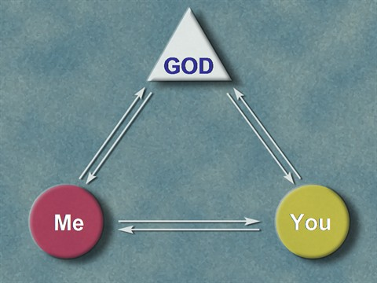

* We must be in right relationship with God and others
* When one is thrown off, the others are messed up

Foundation Picture #2:

oundation Picture #2 
• Presenting Problem 
• Real Problem 
• deeper a

* Most problems are symptomatic problems stemming from a true, root, real problem
* Real problems may be spiritual, physical, or mental

Foundation Picture #3

3 
Time 
01 str egies 
Orientation 

* White line is when life has "meaning, purpose, and manageability"
* The Orange dotted line is when life has lost any one or multiple of those.

Foundation Picture #4

elatio 
ship Funnel 
Shallow disclosure 
& feedback 
'Speaking the truth in love" 

* Jesus did this:
  + James, John, Peter
  + The Twelve
  + The 70
  + The Masses

**Application Strategies**

1. Truth vs. UnTruth 
1. Unhealthy 

* This is the "Truth Journal." The person fills in each blank.
* 3 categories of reflection:
  + Is there any place where I had bad theology?
  + Is there any place where I had irrational beliefs?
  + Is there any place where I had an unrealistic expectation?

ncounter fallemworlgi 
reaction: feaö? 
ujlt' frustration 'sadness: 


elf-Estee 
Performance 
Expectations 
Comparison 
• temporal 
• conditional 
achiev

Unrelated: Some Christians are depressed. Most are not. However, this does not mean that most Christians are walking in the joy of the Lord. This probably means that some Christians are depressed, some are walking in the joy of the Lord, and a great number are keeping depression at bay by way of idolatry.

4. Stress Stressors 
External choic

* If you're stressed, you may need to get rid of some external stressors.
  + Some stressors you can't get rid of. Some you can.
  + Many stressors are often idols that need to be thrown out anyway (GPA, getting rich, getting ripped)
* Not only must we get rid of stressors, we have to increase supports:
  + Physical (get sleep, eat, and exercise
  + Social interactions
  + Spiritual community (fellowship and corporate worship)

4.Stress Stressors 
Internal choice

neness Choices 
"l Do" choose us 
of Oneness 
Erosion Choices 
5 
5 
6 
Don't" 

ameness 
• Three identities: "Me," "'You," Us" 
• Each must make "I choose us' 
cho

* Unity despite differences, not finding someone who likes everything you like and dislikes everything you dislike

**Worldviews and Integration Models**

5 Factors of a Worldview

1. Epistemology - how do you know what you know?
2. Metaphysics - What do you believe about the universe?
3. Theology - What do you believe about God?
4. Anthropology - What do you believe about mankind?
5. Ethics - How should you live?

Christian Worldview

Epistemology

* Special Revelation: Truth
* General Revelation: truth

pparent Conflicts of Truth 
(Four Pössibi/it/esj) 
Data of Theolo

Integration Models:

Against - 2 separate sources of truth in an oppositional stance to one another

* Secular
  + Truth - Scientific method
  + Religion's potential destructiveness: causes inhibitions and guilt
  + Disorders and solutions are psychological
* Sacred
  + Truth - Revelation
  + Religion's potential destructiveness: removes inhibitions and guilt
  + Disorders and solutions are spiritual
  + Nouthetic Counseling
    - Problems are sin-caused, and healing takes place through identification of sin and repentance

Of - 2 separate expressions of truth, not two sources of truth

* Secular
  + Epistemology: Pantheism, humanism, or naturalism broader than a reductionist naturalism
  + People: spiritual-moral beings
  + Value of Religion: most religions are good
  + Sin: Psychological/enviornmental
* Sacred
  + Epistemology: Scripture and religious experiences are valid sources of truth, but not in a clearly supernatural way
  + People: spiritual-moral beings
  + Religion: Symbolic
  + Sin: religious symbol for psychopathology
  + Psychology & religion: good religions uses psychological principles in religious setting with religious metaphors

Parallels - There are two separate sources of truth (secular and sacred), with no integration

* Most commonly practiced model

Integrates - 2 methods and 1 source of truth

LJlffjITIfEjry Ui FOLJIJj/JÉlt10fjÉIlJ jVJlogJU]3 
1M 
Odel Type bisciÅ/iqeö Trgöhp